**Preguntas de revisión**

* Preguntas en azul.
* Respuestas en verde.

1. The code between a pair of curly braces in a method is a:
2. function
3. block
4. brick
5. sector
6. When a block exists within another block, the blocks are:
7. structured
8. nested
9. sheltered
10. illegal
11. The portion of a program within which you can reference a variable is the variable’s:
12. range
13. space
14. domain
15. scope
16. You can declare variables with the same name multiple times:
17. within a statement
18. within a block
19. within a method
20. You never can declare multiple variables with the same name.
21. If you declare a variable as an instance variable within a class, and you declare and use the same variable name within a method of the class, then within the method:
22. the variable used inside the method takes precedence.
23. the class instance variable takes precedence.
24. the two variables refer to a single memory address.
25. an error will occur.
26. A method variable ___ a class variable with the same name.
27. acquiesces to
28. destroys
29. overrides
30. alters
31. Non ambiguous, overloaded methods must have the same:
32. name
33. number of parameters
34. parameter names
35. types of parameters
36. If a method is written to receive a double parameter, and you pass an integer to the method, then the method will:
37. work correctly; the integer will be promoted to a double.
38. work correctly; the integer will remain an integer.
39. execute, but any output will be incorrect.
40. not work; an error message will be issued.
41. A constructor ___ parameters.
42. can receive.
43. cannot receive.
44. must receive.
45. can receive a maximum of 10.
46. A constructor ___ overloaded:
47. can be.
48. cannot be.
49. must be.
50. is always automatically.
51. Usually, you want each instantiation of a class to have its own copy of:
52. the data fields.
53. the class methods.
54. both above.
55. none of the above.
56. If you create a class that contains one method and instantiate two objects, you usually store for use with the objects:
57. one copy of the method
58. two copies of the method
59. two different methods containing two different “this” references.
60. data only (the methods are not stored)
61. The “this” reference:
62. can be used implicitly.
63. must be used implicitly.
64. must not be used implicitly.
65. must not be used.
66. Methods that you reference with individual objects are:
67. private
68. public
69. static
70. non-static
71. Variables that are shared by every instantiation of a class are:
72. class variables
73. private variables
74. public variables
75. illegal
76. The keyword final used with a variable declaration indicates:
77. the end of the program.
78. a static field.
79. a symbolic constant.
80. that no more variables will be declared in the program.
81. Java classes are stored in a folder or:
82. packet
83. package
84. bundle
85. gaggle
86. Which of the following statements determines the square root of a number and assigns it to the variable ‘s’?
87. s = sqrt(number);
88. s = Math.sqrt(number);
89. number = sqrt(s);
90. number = Math.sqrt(s);
91. A GregorianCalendar object can be created with one of seven constructors. This means that the constructors:
92. override each other.
93. are ambiguous.
94. are overloaded.
95. all of the above.
96. The GregorianCalendar class get() method always returns a(n):
97. day of the week.
98. date
99. integer
100. GregorianCalendar object.

**Ejercicios de programación**

* Enlaces a los archivos en azul.

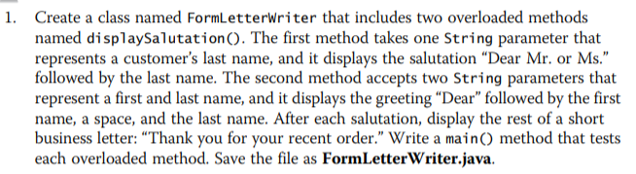

Enlace al archivo: <https://github.com/logralahad/POO1_Capitulo4/tree/main/chapter4_Joyce/src/ejercicio1>

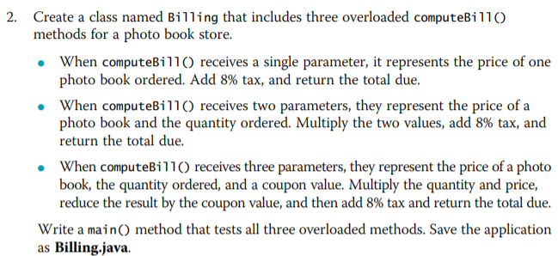

Enlace al archivo: <https://github.com/logralahad/POO1_Capitulo4/tree/main/chapter4_Joyce/src/ejercicio2>

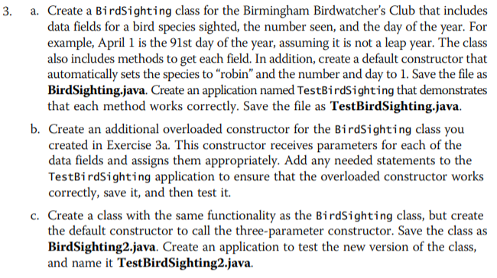

Enlace al archivo: <https://github.com/logralahad/POO1_Capitulo4/tree/main/chapter4_Joyce/src/ejercicio3>

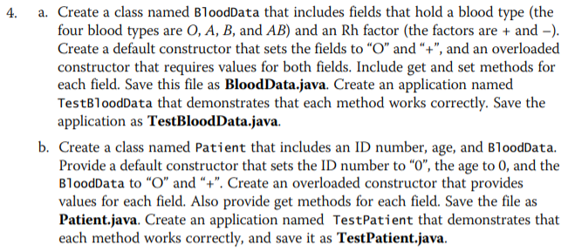

Enlace al archivo: <https://github.com/logralahad/POO1_Capitulo4/tree/main/chapter4_Joyce/src/ejercicio4>

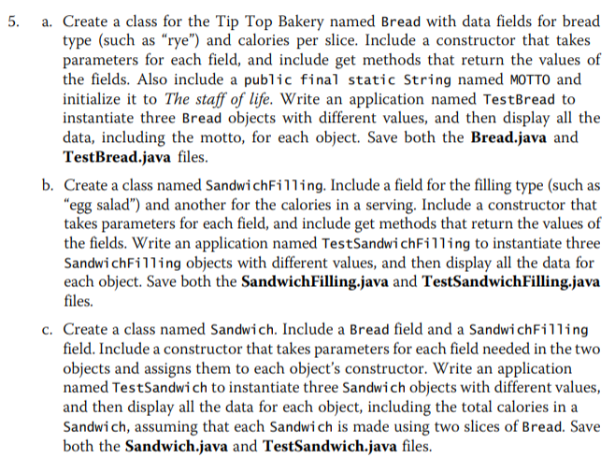

Enlace al archivo: <https://github.com/logralahad/POO1_Capitulo4/tree/main/chapter4_Joyce/src/ejercicio5>

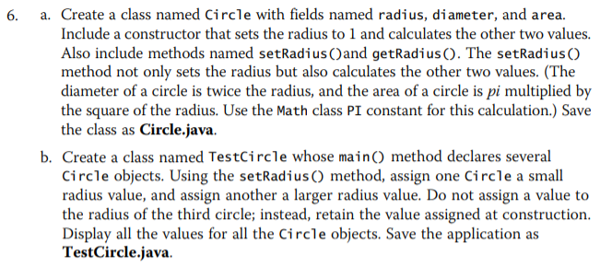

Enlace al archivo: <https://github.com/logralahad/POO1_Capitulo4/tree/main/chapter4_Joyce/src/ejercicio6>

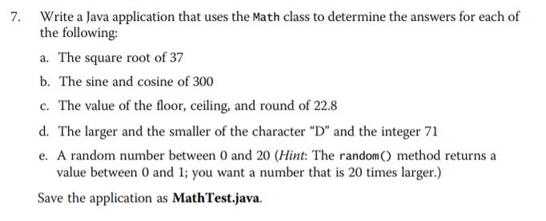

Enlace al archivo: <https://github.com/logralahad/POO1_Capitulo4/tree/main/chapter4_Joyce/src/ejercicio7>



Enlace al archivo: <https://github.com/logralahad/POO1_Capitulo4/tree/main/chapter4_Joyce/src/ejercicio8>

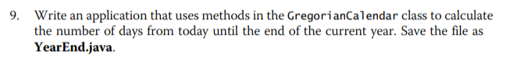

Enlace al archivo: <https://github.com/logralahad/POO1_Capitulo4/tree/main/chapter4_Joyce/src/ejercicio9>

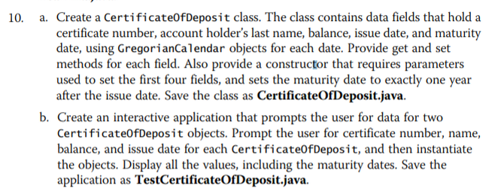

Enlace al archivo: <https://github.com/logralahad/POO1_Capitulo4/tree/main/chapter4_Joyce/src/ejercicio10>

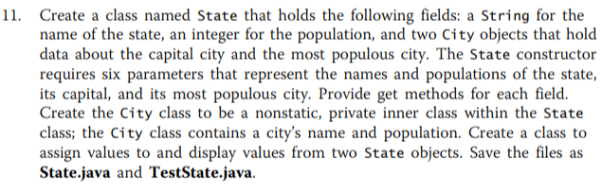

Enlace al archivo: <https://github.com/logralahad/POO1_Capitulo4/tree/main/chapter4_Joyce/src/ejercicio11>

**Game Zone**

* Enlaces a los archivos en azul.

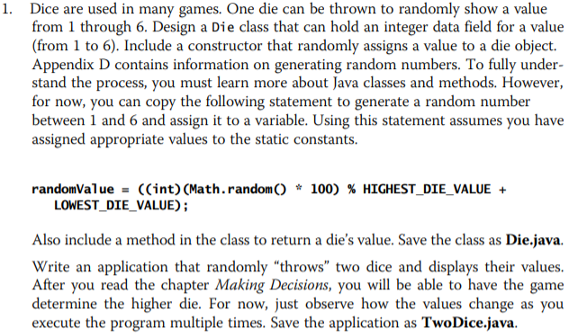

Enlace al archivo: <https://github.com/logralahad/POO1_Capitulo4/tree/main/chapter4_Joyce/src/gameZone1>

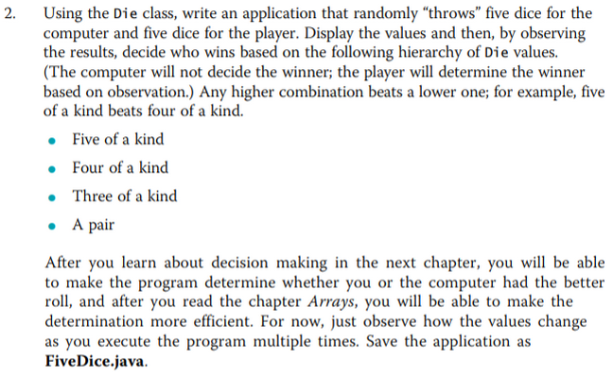

Enlace al archivo: <https://github.com/logralahad/POO1_Capitulo4/tree/main/chapter4_Joyce/src/gameZone2>

**Case Problems**

* Enlaces a los archivos en azul.

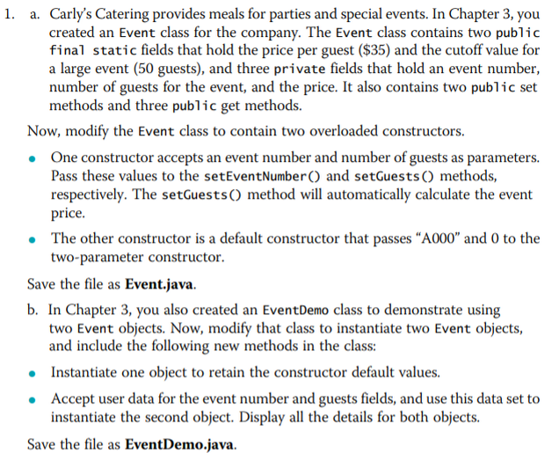

Enlace al archivo: <https://github.com/logralahad/POO1_Capitulo4/tree/main/chapter4_Joyce/src/caseProblem1>

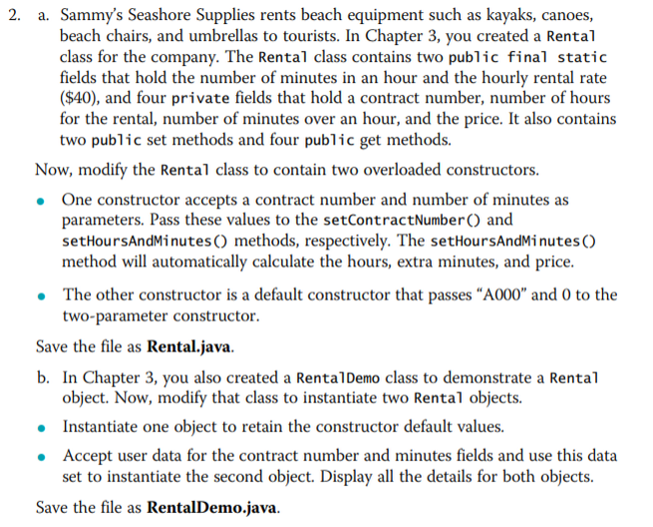

Enlace al archivo: <https://github.com/logralahad/POO1_Capitulo4/tree/main/chapter4_Joyce/src/caseProblem2>